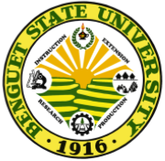
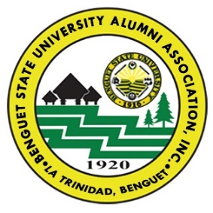
2020 SEARCH FOR ALUMNI COUPLE AWARD
NOMINATION FORM
(This form may be downloaded at bsu.edu.ph, may be reproduced
and send back by postal or email on or before the set deadline)

========================================================================================

In celebration of the Centennial Anniversary and Alumni Homecoming of BSU Alumni Association on September 26, 2020, there is a search for alumni who became couples and embodied the ideals of the university to serve communities with utmost dedication.

Name of Nominee  First Name, Family Name, Middle Initial | Degree and Year Graduated | Employment or Highest Position/Designation held
Husband:

Wife (maiden name):

Family Address: ____________________________________________________________________________________________________

Contact number: _____________________________

Submit the following:
- Duly accomplished Nomination Form.
- Optional. A brief narrative profile of nominee indicating achievements/contributions to BSU and/or community deserving recognition (not more than 2 pages). Include list of recognition awards received and that of your children if any.
- Optional. Family photo with at least 1020 pixels in jpeg or png if sent through email.

Note: Submit all the required documents on or before January 20, 2020 (for international nominees) and July 20, 2020 (for local nominees). For details contact:
The Chairman, 2019 Search for Outstanding Alumni
BSUAAI Office, BSU Alumni Center, BSU Cpd. Betag, La Trinidad, Benguet 2601, Philippines. Tel. No. (063)(74)309-3878 or 09088647520 Fb Page: BsuAlumni La Trinidad
Email address: alumni.association@bsu.edu.ph or l.colting@gmail.com

Nominator (optional): (Self-nomination is accepted). This is to certify that that the entries are true and correct to the best of my knowledge.
Name and Signature: ________________________________________________________
Contact number: _________________ Email address: ______________________________

Date submitted: _________________

